PROJECT: PERSONAL BLOG ON IBM CLOUD STATIC WEB APPS

PHASE 3: DEVELOPMENT PART -1

TOPIC: ” Building modern websites with IBM cloud static web apps: A step by step guide”

INTRODUCTION:

Creating a personal blog using cloud static web apps is a great idea. You can use services like AWS Amplify, Azure Static Web Apps, or Notify to host your static website. Here’s a basic outline of the process:

STEPS INVOLVED IN DEVELOPMENT:

1. How to start a travel blog
2. Choose the type of travel blogger you want to be.
3. Pick a blog name and secure your domain name.
4. Select your travel blog template.
5. Create a blog logo.
6. Prepare your footage.
7. Write your first blog posts.
8. Engage with your audience.
9. Network with tourism partners and brands.

DEVELOPING PROCESS STEPS TO BE TAKEN:

Sign up for an IBM Cloud account if you don’t have one already.

Install the IBM Cloud CLI tool on your local machine.

1. Choose a Static Site Generator:

Select a static site generator, such as Jekyll, Hugo, Gatsby, or any other that you prefer, to build your blog.

1. Create Your Blog:

Build your personal blog locally using your chosen static site generator. You can create pages, write blog posts, and design the layout.

1. Version Control:

Use a version control system like Got to track changes in your blog. Initialize a Got repository in your project directory and commit your code.

1. IBM Cloud CLI:

Log in to IBM Cloud using the IBM Cloud CLI:

* Copy code
* Ibmcloud login
* Create an IBM Cloud Static Web App:
* Create a new static web app on IBM Cloud. This is where your blog will be hosted. You can use the IBM Cloud web console or the CLI.
* Configure the app’s name, region, and other settings.

1. Upload Your Blog:

Use the IBM Cloud CLI or the web console to upload your blog files to the static web app. This typically involves using the ibmcloud static-web-apps deploy command.

1. Domain Configuration:

If you have a custom domain, configure it to point to your IBM Cloud static web app. This involves setting up DNS records.

1. SSL Configuration:

Enable SSL for your custom domain to ensure secure browsing.

1. Access Control and Authentication (Optional):

Configure access control and authentication if you want to protect certain parts of your blog or require user logins.

**How to build a website using HTML**

You must be aware of all the basic concepts and techniques associated with HTML before compiling all of it to create a website using HTML and CSS. There are multiple actions you are going to perform while writing code in HTML.

How To View the Source Code of an HTML Document?

Every webpage on the internet uses HTML to structure its webpage and display it. To view the source code of any webpage, navigate to the webpage, right-click on the page and then select “view page source”. Moreover, you may use a keyboard shortcut CTRL + U or CMD + U to inspect the source code of any HTML document.

The source code of an HTML document will look something like this.

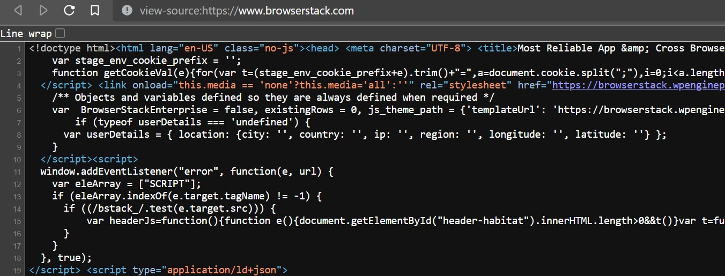

**Understanding and using HTML Elements**

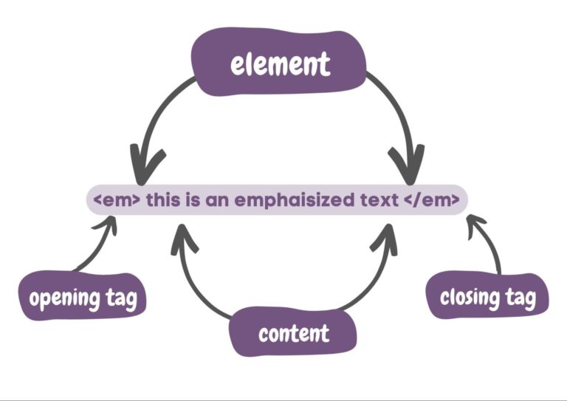In HTML, elements are the building blocks for an HTML document. It usually contains an opening tag, a closing tag, and the content between them. It helps browsers to interpret in classifying the content, such as headings, images, paragraphs, and more.

<em> This is an emphasized text </em>

In this example, it tells the browser to interpret and render this HTML element as an emphasized text.

**Using Inline-level and Block-level Elements in HTML**

Block-level elements in HTML are those elements that always start on a new line and occupy the complete width of the screen. Some popular block-level elements are, <p>, <div>, <table>, and more.

Inline-level elements are those elements that occupy only the necessary width and do not start on a new line.

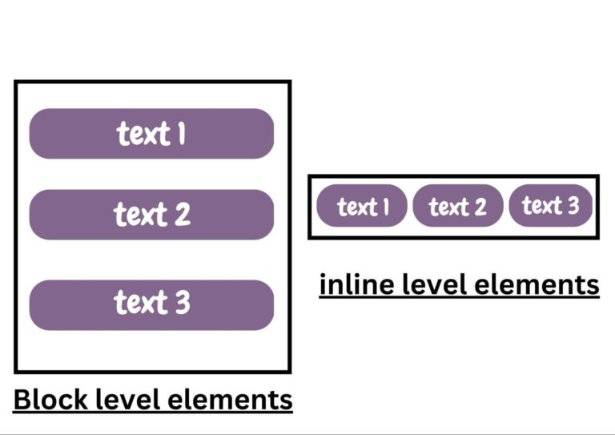**How To Nest HTML Elements**

Nesting in HTML is to apply several HTML tags to a single content. In nesting, one element can be placed inside other elements. Another benefit of nesting in HTML includes improving the readability of your code for you and other developers.

Nesting in HTML will look something like this.

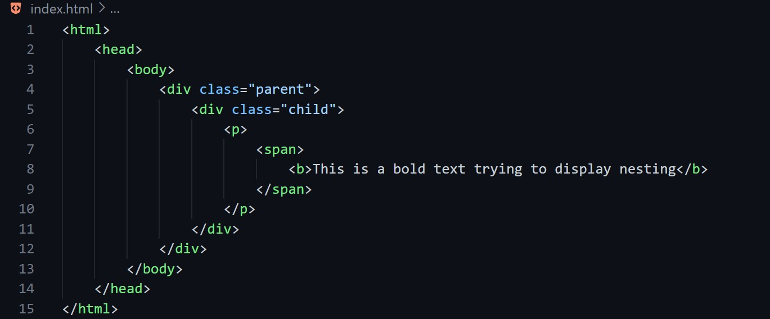

**How to build a website using CSS**

Understanding and Creating CSS Rules

CSS rules also known as rulesets and are a combination of one or more CSS properties that you can apply to one or more HTML elements. It consists of a CSS selector and CSS properties. It determines what to style to a targeted HTML element.

Div {

Border-color: black;

Font-size: 2rem;

}

In this instance, it creates a CSS rule targeting the div element and creating CSS properties, border–color, and font-size to be the style for the div element.

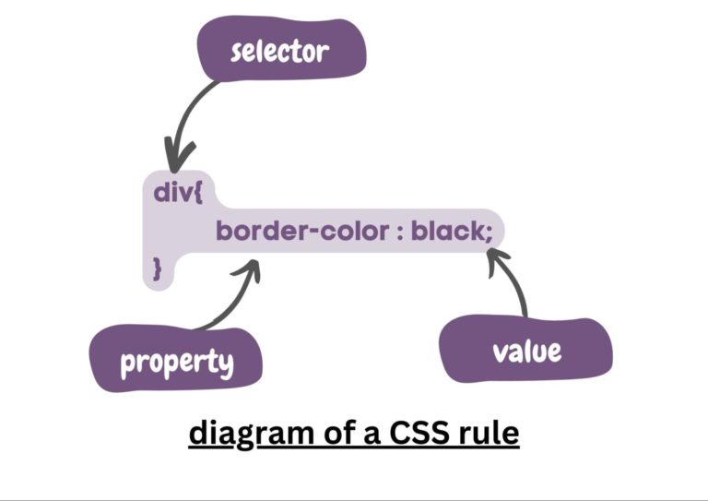

**Declaring Values For Multiple Properties In a CSS Rule**

In this section, let us learn how to declare values for multiple properties in a CSS rule. This is very helpful as it allows you to apply several style instructions to an HTML element all at once. In simpler words, for instance, if you want to apply border–color, font-size, and more to a div tag, you can do that all at once.

Div {

Border-color: brown;

Font-size: 2rem;

Font-family: ‘Times New Roman’;

}

**Style Images With CSS**

In this section, let’s learn how to style images with CSS such as adding a border to an image, adjusting its dimensions, and further specific CSS to our images in the webpage. First, add an image element in the HTML file.

<img src=”doggo.jpg” alt=”Image of Doggo”>

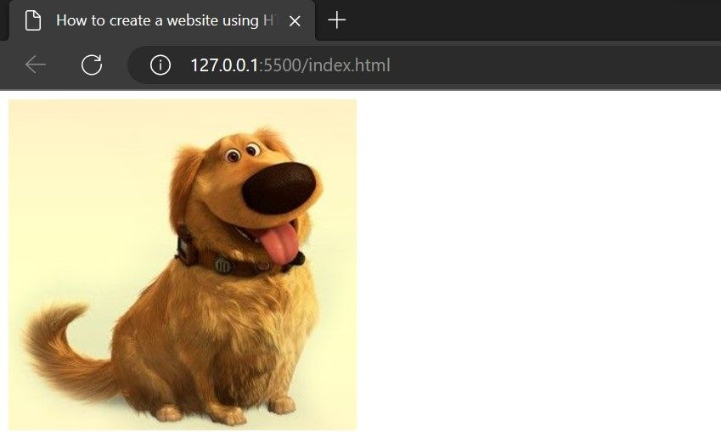

Now, it’s time to add CSS to the image to make it look good.

Img{

Height: 300px;

Border-radius: 50%;

Border: 12px dotted rgb(255, 85, 0);

}

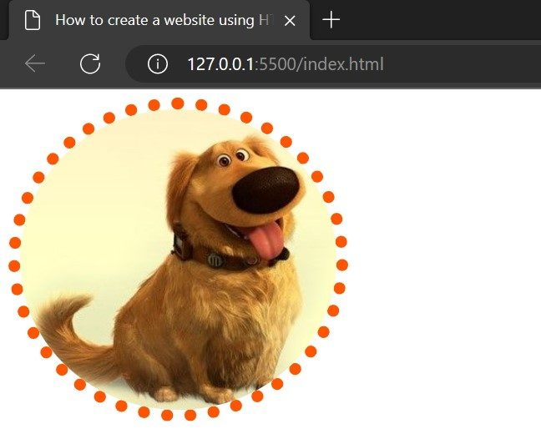

**Styling Classes With CSS**

Now, let’s see how to create classes with the help of CSS. Here, we shall learn how to apply CSS rules only to the HTML elements that have specific classes. First, let’s create an HTML element that has some class, and then we shall apply CSS to the entire class. Applying CSS to the entire class will allow us to style all the elements that have the particular class.

<img src=”dog background.jpg” alt=”” class=”blueBorder”>

<h2 class=”blueBorder”>My name is Doggo</h2>

<p class=”blueBorder”>Lorem10</p>

In this example, we took three different elements having the same class. Once we apply CSS to the class, it will be applied to all the elements belonging to the same class.

.blueBorder{

Border: 12px solid blue;

}

To use the class as a selector while creating a CSS rule, we use the ‘.’ Symbol before writing the class name in the CSS file.

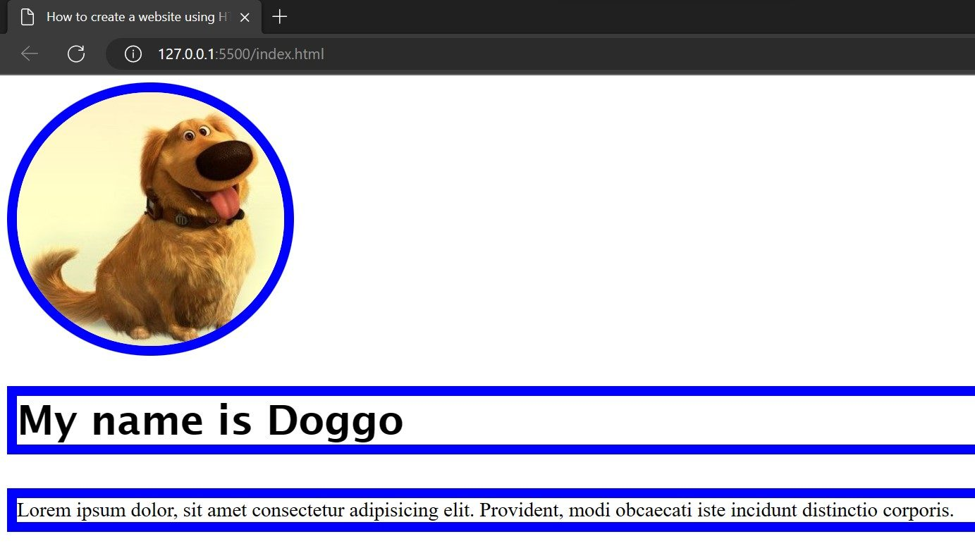

**Styling IDs with CSS**

Using IDs as selectors while creating CSS rules is similar to using classes as selectors, however, IDs are unique in the HTML document and no two elements can carry the same IDs. IDs are generally applied to the elements which are present only one time in the HTML document such as the navbar, logo, and more.

<h2 id=”BrowserStack”>Using ID as a CSS selector</h2>

Now, let’s create a CSS rule, using ID as a selector.

#BrowserStack{

Font-size: 2rem;

Color: blueviolet;

Background-color: bisque;

}

Img:hover{

Border: 12px dotted blue;

}

**Styling HTML <div> element with CSS**

The div tag is often used to specify the container for HTML elements. It can also be used to structure the layout of the webpage. Now, let’s understand how to style the div element and its children elements.

Div{

Background-color: bisque;

Border: 10px solid rgb(232, 69, 69);

Border-radius: 2%;

Height: 50vh;

Width: 50vh;

}

**How To Adjust the Content, Padding, Border, and Margins of an HTML Element With CSS**

Before understanding how to adjust the content, padding, border, and margins of an HTML element, let’s understand the CSS box model. It is a box that wraps around every HTML element in the DOM.

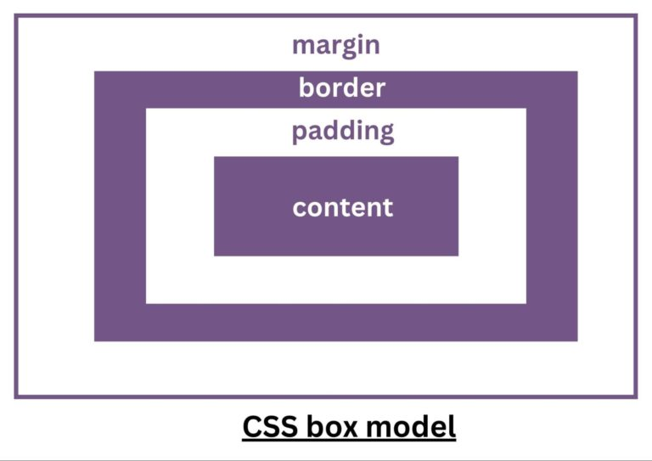

Content box: It is the space where the content of the HTML element appears, such as images, text, and more.

Padding: It is the transparent area around the content of the element.

Border: It is the box surrounding the padding box. By default, the value of the border for every HTML element is zero; however, increasing the border value increases the space between the padding and the margin box.

Margin: It is the transparent area outside the border box.

Img{

Height: 300px;

Border-radius: 50%;

Border: 12px dotted rgb(255, 85, 0);

Padding: 10px 10px 20px 20px;

Margin: 20px 20px 15px 10px;

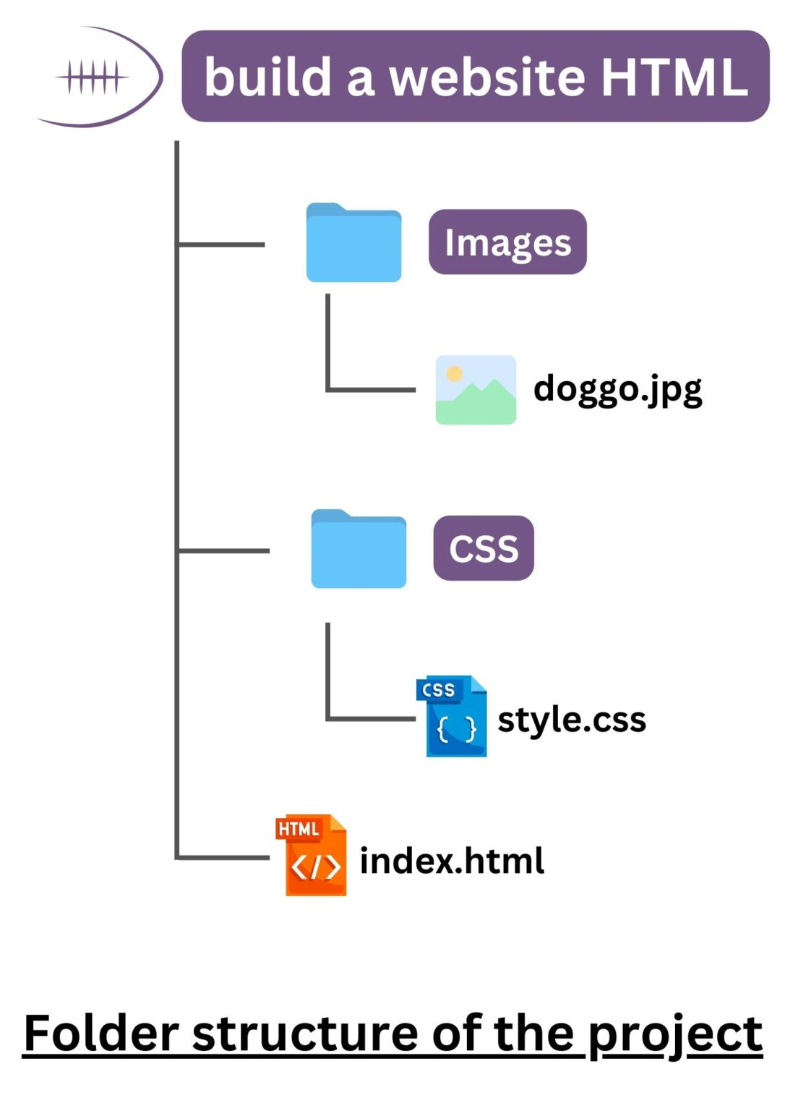}

**How To Create A Layout And Build A Website Using HTML And CSS**

**In this section, let’s create a full-fledged website using only HTML and CSS. Most of the users have a question today – Can you create a website just using HTML and CSS?**

**It is quite possible to create a good-looking website with the help of only HTML and CSS. HTML stands for Hypertext markup language and provides the skeleton for our website. However, CSS (Cascading Style Sheet) allows the skeleton to be more good-looking. Let us use seven steps to create a good-looking website from scratch.**

**Step 1: Create a Layout**

**First create a basic structure of your website as a rough sketch. There are a lot of free online services that will help you design your website. Nonetheless, you must have a basic structure of the website ready.** 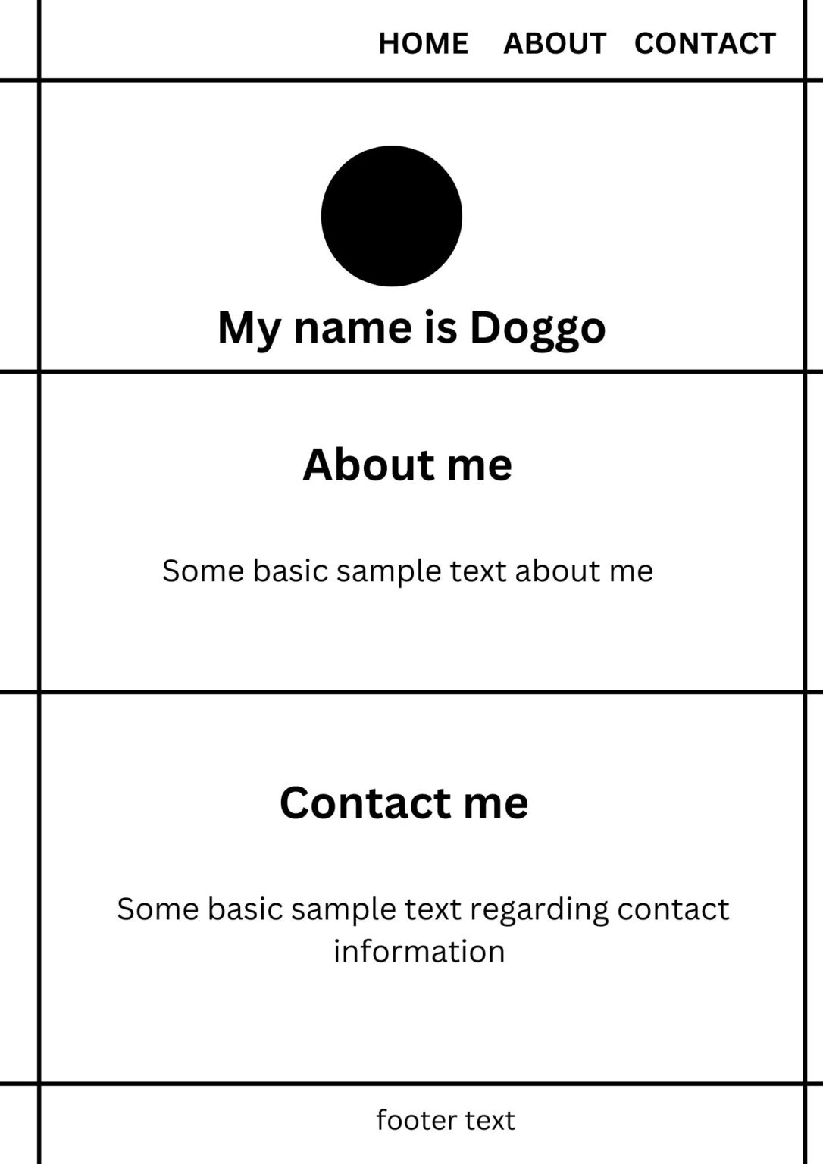

Step 2: Set up the boiler code

**Create a new project folder and create an empty index.html file inside the folder. Here, add the boilerplate code to the HTML file.**

<!DOCTYPE html>

<html lang="en">

<head>

<meta charset="UTF-8">

<meta name="viewport" content="width=device-width, initial-scale=1.0">

<title>How to create a website using HTML and CSS</title>

<link rel="stylesheet" href="css/style.css">

</head>

<body>

<header>

</header>

<main>

<section id="intro">

</section>

<section id="about">

</section>

<section id="contact">

</section>

</main>

<footer>

</footer>

</body>

</html>

**Step 3: Create major elements in the layout**

<!DOCTYPE html>

<html lang="en">

<head>

<meta charset="UTF-8">

<meta name="viewport" content="width=device-width, initial-scale=1.0">

<title>How to create a website using HTML and CSS</title>

<link rel="stylesheet" href="css/style.css">

</head>

<body>

<header>

</header>

<main>

<section id="intro">

</section>

<section id="about">

</section>

<section id="contact">

</section>

</main>

<footer>

</footer>

</body>

</html>

* **Step 4: Create the HTML content**

In the previous step, you had created the elements in the layout. In this step, fill in the HTML content. Note that, in this example,  let us fill the content with dummy text only.

<!DOCTYPE html>

<html lang="en">

<head>

<meta charset="UTF-8">

<meta name="viewport" content="width=device-width, initial-scale=1.0">

<title>How to create a website using HTML and CSS</title>

<link rel="stylesheet" href="css/style.css">

</head>

<body>

<header>

<nav>

<ul>

<li><a href="#intro">Home</a></li>

<li><a href="#about">About</a></li>

<li><a href="#contact">Contact</a></li>

</ul>

</nav>

</header>

<main>

<section id="intro">

<div class="Container">

<img src="Images/doggo.jpg" alt="display picture of doggo">

<h2>My name is Doggo</h2>

</div>

</section>

<section id="about">

<div class="container">

<h1>About Me</h1>

<p>Lorem ipsum dolor sit amet consectetur adipisicing elit. Sint, similique?</p>

<ul>

<li>Btech Qualified</li>

<li>Software Engineer</li>

<li>GATE AIR 01</li>

</ul>

</div>

</section>

<section id="contact">

<div class="container">

<h1>Contact me</h1>

<p>Lorem, ipsum dolor sit amet consectetur adipisicing elit. Nam, laudantium.</p>

<ul>

<li>Email ID</li>

<li>Insta ID</li>

<li>Facebook ID</li>

</ul>

</div>

</section>

</main>

<footer>

<p>© Copyright 2022 Doggo Co LTd.</p>

</footer>

</body>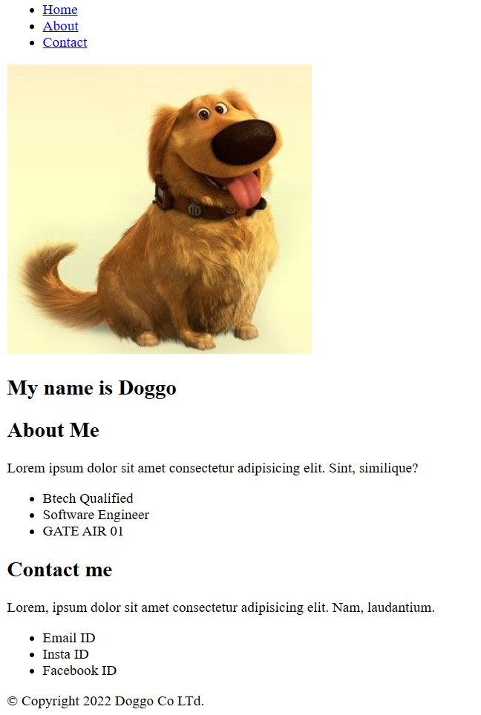

</html>

**CONCLUSION:**

**IBM Cloud Static Web Apps offer a powerful and flexible solution for hosting and deploying your static websites. With features like automatic , serverless functions, and scalability, it simplifies the development process and ensures a seamless user experience. Whether you’re a developer looking for an efficient way to host your personal website or a business seeking to create a reliable web presence, IBM Cloud Static Web Apps is a valuable tool to consider. Its integration with the IBM Cloud ecosystem and support for modern web technologies make it a strong choice for web hosting and development. So, if you’re in search of a platform to bring your web projects to life, give IBM Cloud Static Web Apps a try and see how it can enhance your web development experience.**